NEXTGEN SOFTWARE UPGRADE AND REPAIR

Revision 1.1

NEXTGEN SOFTWARE UPGRADE AND REPAIR 1
Revision 1.1 1
Glossary 3
Introduction 3
Creating an Upgrade File 4
Option Combinations And Restrictions 6
Changing Version Numbers 6
Layout of the Upgrade File 6
Upgrade File Limitations 8
System Self Repair 8
Upgrading a System Using an Upgrade File 13
Initial Screens 14
System Software Screens 15
Motor Board Software Screens 21
Final Screens 27
Top Level Error Screens 29
Example Screen Sequences and User Actions 30
References 31

Glossary
NextGen platform
A common hardware and software platform architecture that is used for implementing devices like the DYONICS™ 25 Fluid Management System and the DYONICS™ Power Shaver System. Contains USB port(s) for upgrade purposes.
Motor Board
NextGen component board that is based on a Motorola DSP56F8357 processor. The software for this board is comprised of:
- Factory loaded boot software (not field upgradeable)
- Application software (field upgradeable) (a.k.a. Motor Board Software)
Base Board
NextGen component board that contains a LogicPD ARM-based CPU module. The software for this module contains the following pieces of software:
- Factory loaded boot software (not field upgradeable)
- Application software (field upgradeable) (a.k.a. System Software)
USB Flash Drive
The delivery medium for software upgrades. Formatted as a Win32 file system.
Upgrade File
File on the USB Flash Drive that contains upgrade information in a custom format. This file must be named “NextGen.upg” and reside in the root directory of the USB Flash Drive.
buildupgrade
Console application on a host PC that is used to create an upgrade file from software for the Motor board and the Base Board
Main Application
End user application that runs on the NextGen platform e.g. the pump application or the shaver application

Introduction
The NextGen platform is designed for field software upgrades via a USB Flash Drive connected to one of its USB ports. This document describes:
- How to create an Upgrade File on a host PC
- The layout of the Upgrade File
- Using the Upgrade File To Upgrade A System
- System Self Repair

All screen shots in this document are given for the English language only. Every screen has been translated to the following languages:
- English
- German
- Italian
- Spanish
- French
- Swedish
- Danish
- Dutch
- Portuguese
- Norwegian

Creating an Upgrade File
The buildupgrade tool is used to create an Upgrade File from various components. The executable must be run in the VSS directory Next-Gen\Software\Common Software\Tools\BuildUpgrade, because it looks for some default run-time files in that directory. It outputs informative messages, warnings and errors on the console (DOS window). The exit status to the shell is 0 if it succeeds with no errors.

The following diagram shows a process overview of the tool:
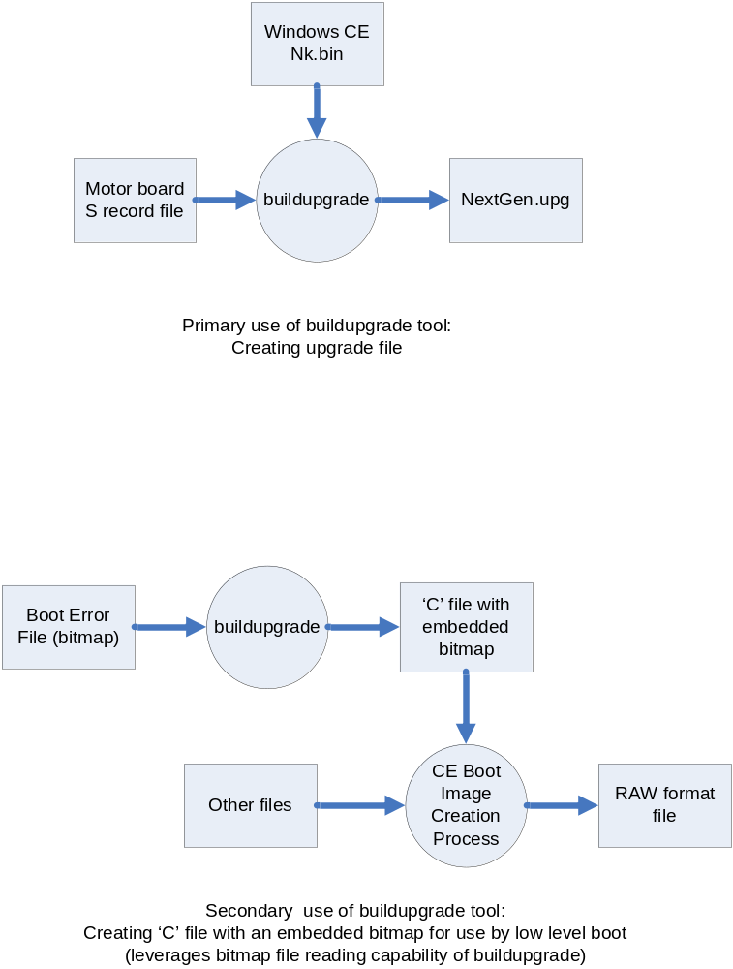

This tool takes the following arguments, all arguments are case sensitive:
Option | Default Value | Must be specified? | Description
-splash <pcSplashFile> | None | Yes | <pcSplashFile> is the pathname of a bitmap file (.bmp) to use for the splash screen of the application. Not all bitmap formats are supported, only those with an ID of 0x4D42.
-base <qSplashScreenRamStart> | 0xC1C00000 | No | < qSplashScreenRamStart> is the address in RAM where the splash screen should be placed. CAUTION: Do not change the default value unless the target hardware supports it.  Hex values need a leading “0x”.
-nk <pcNkFile> | None | No | <pcNkFile> is the pathname of the output of the Windows CE tools, in “.bin” format.
-srec <pcSRecFile> | None | No | <pcSRecFile> is the pathname of the output of the Metrowerks IDE for the DSP56F8357 processor on the Motor Board, in S record format. See reference document for details regarding configuring the Metrowerks IDE to output in this format.
-booterr <pcBootErrFile> | None | Yes | <pcBootErrFile> is the pathname of a bitmap file (.bmp) to use for the boot error splash screen. Not all bitmap formats are supported, only those with an ID of 0x4D42.
-out <pcOutFile> | NextGen.upg | No | Pathname of the output file for this tool. If the –out argument is used, the basename of the output file should still be “NextGen.upg”, otherwise it will not be recognized by the sytem as an upgrade file. This option is useful for specifying a different directory where the output file should be placed (e.g. the USB Flash Drive itself).
-vers <SoftwareVersion> | None | Yes | <SoftwareVersion> is of the form DN.DN or DN.DN.DN, where DN is a decimal number. The three decimal numbers represent the major, minor and build versions in that order; if the build version is omitted, it is set to 0.

Option Combinations And Restrictions
- The –nk and –splash options must be used together.
- The output file cannot be empty, that is, it should contain upgrade information for at least one board

Changing Version Numbers
There are three version numbers that are presented to users of the device:
- The overall “Software version”
- The Application version on the Base Board
- The Motor Controller version

To change these version numbers:
- The Software Version is obtained from the command line argument “-vers” of the buildupgrade tool.
- The Application Version is embedded in the device application that presents the screen via the string SN_APP_VERSION. Thus the Base Board application needs to be rebuilt, and the builgupgrade tool rerun, to effect this change
- The Motor Controller version is stored in the motor software via the macro MAKE_VERSION. Thus the motor controller software needs to be rebuilt, and the buildupgrade tool rerun, to effect this change.

Layout of the Upgrade File
An Upgrade File can contain upgrade information for the Base Board or for the Motor Board or both boards, in any order. Each part contains a header followed by appropriate information. Each header begins with a “SnQByte qType” which describes what kind of header it is (Base Board of Motor Board), and ends with a byte checksum “SnByte bHdrCrc” to verify the integrity of the header. Other information in the headers is derived from either the input files or command line arguments.

The following diagrams show the layout of the upgrade file, and the derivation of different parts of the file from the input arguments to the tool:
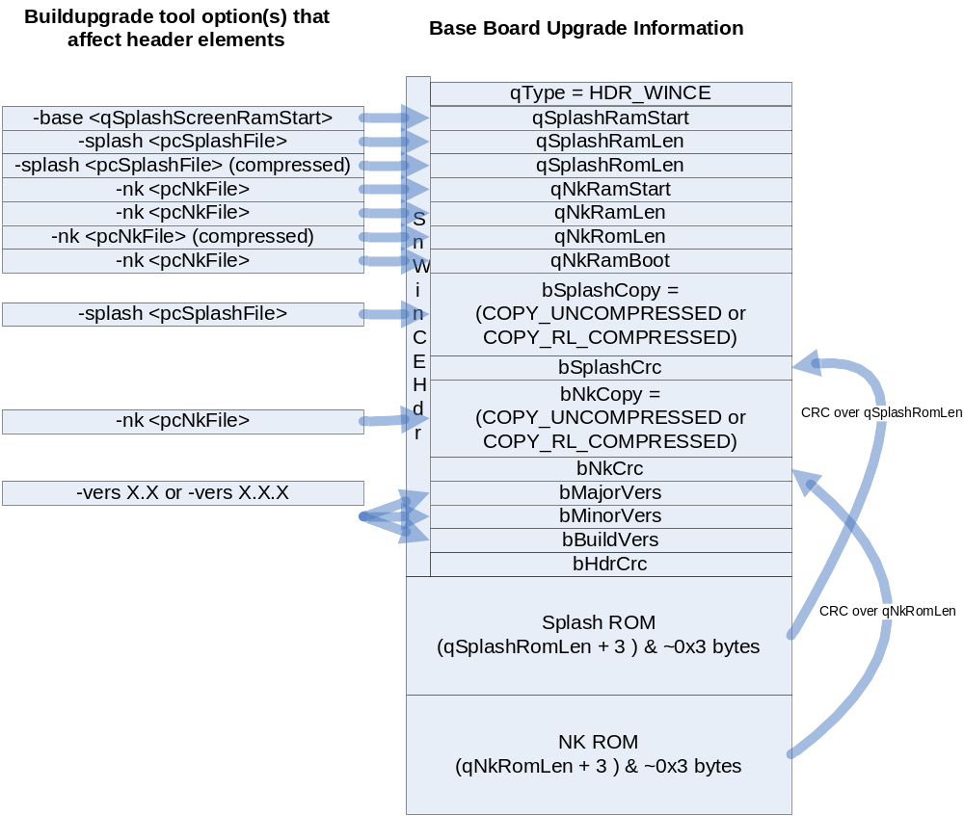
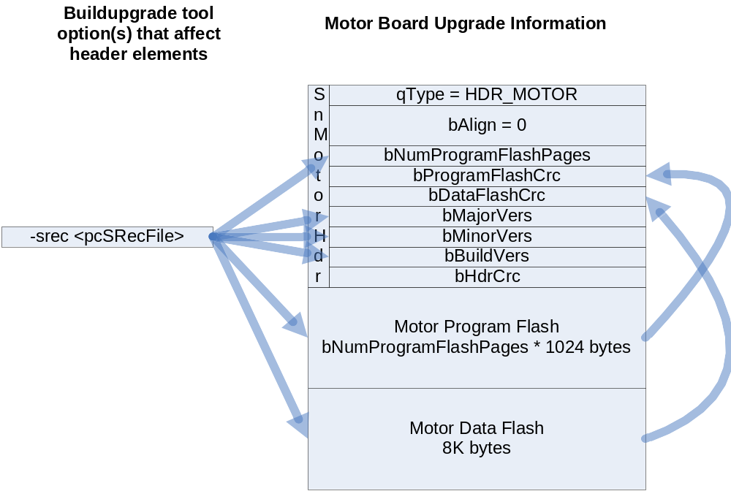

Upgrade File Limitations
A system containing multiple instances of boards is not supported. That is, a system can contain at most one Base Board and at most one Motor Board.

System Self Repair
Two copies of the system application are stored in flash memory for redundancy. Each time the system starts up, both copies are verified. If there is a mismatch, the system will attempt to repair the damaged copy from the good copy, if possible. After the system performs a self repair the system prompts the user to power cycle it. The system will only proceed to a system upgrade once the self repair test passes.

The following screen shots illustrate the repair process. Note that the screen shots were obtained for the case where the “lower” flash area was corrupted; if the “upper” area were corrupted, the sequence would be the same, except that the words “lower” and “upper” on the screens would be exchanged wherever they appear.

Also the following screen shots represent a detailed mode of display. (This is achieved by inserting a Factory Mode USB key in the back of the unit). The default mode of display only will show screens 2, 4, 7.

The following cases are possible:
- One bad copy, and the restore process had no errors. The sequence of screens is 1, 2, 3, 4.
- One bad copy, and the restore process could not read the good copy. The sequence of screens is 1, 6.
- One bad copy, and the restore process could not overwrite the bad copy. The sequence of screens is 1, 2, 7.
- One bad copy, and the restore process could not verify the newly overwritten bad copy. The sequence of screens is 1, 2, 3, 8.
- Two bad copies, no restore is possible. The screen displayed is 5. In this case, there is no Main Application to run. The unit has to be sent back to the factory for repair.

Screen 1: Reading Flash Data
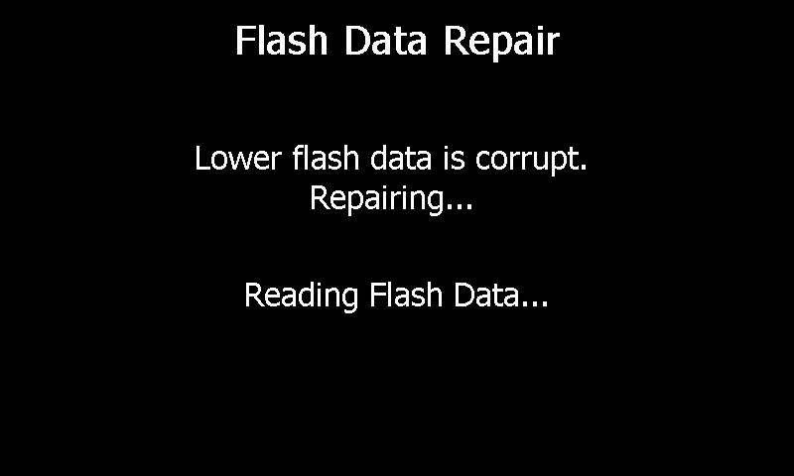

Screen 2: Writing Flash Data
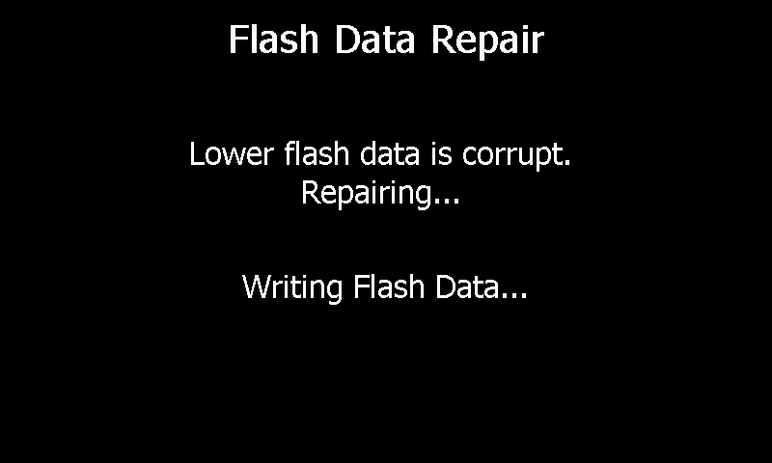

Screen 3: Verifying Flash Data
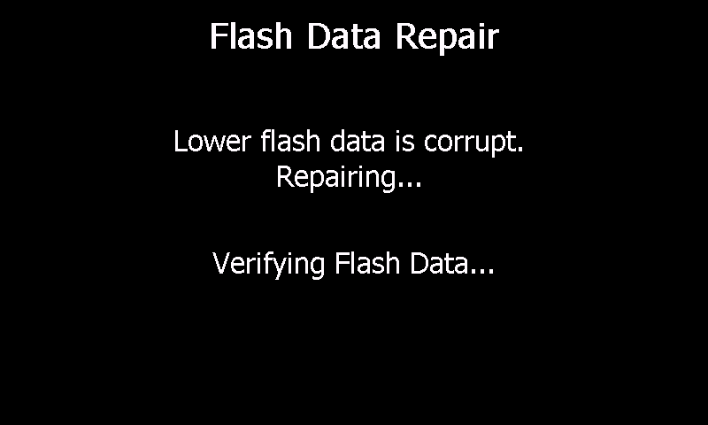

Screen 4: Repair Complete
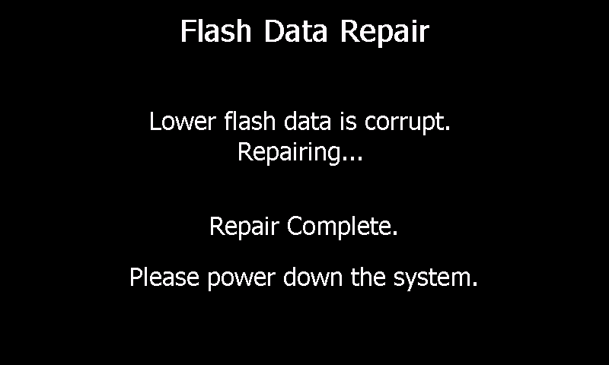

Screen 5: All Corrupt No Repair
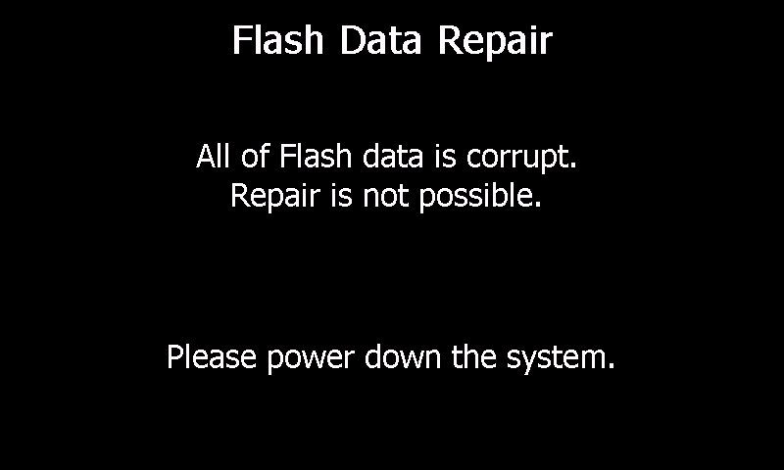

Screen 6: Read Failed
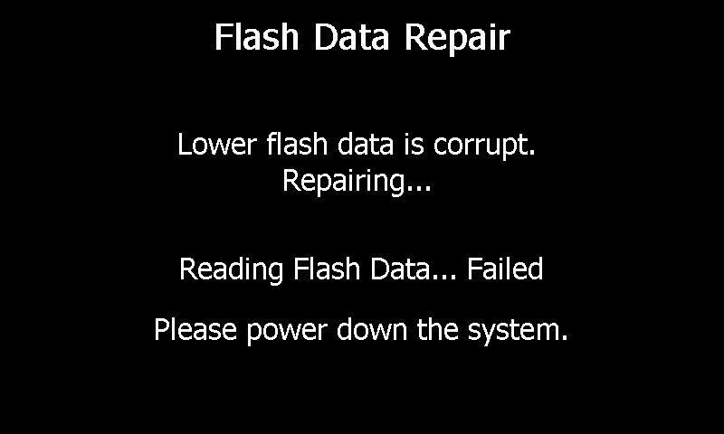

Screen 7: Write Failed
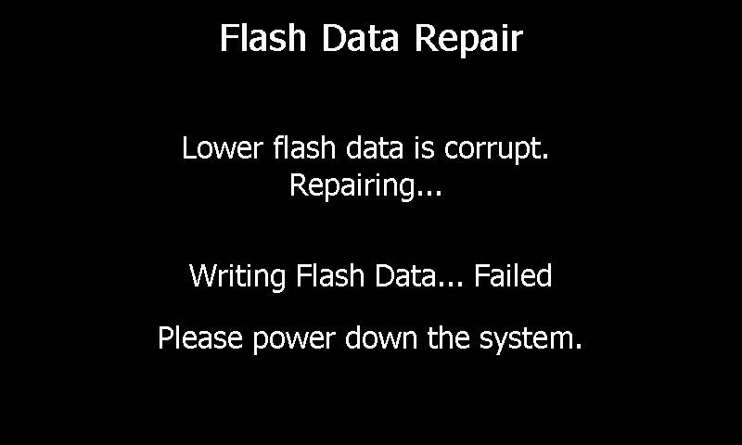

Screen 8: Verify Failed
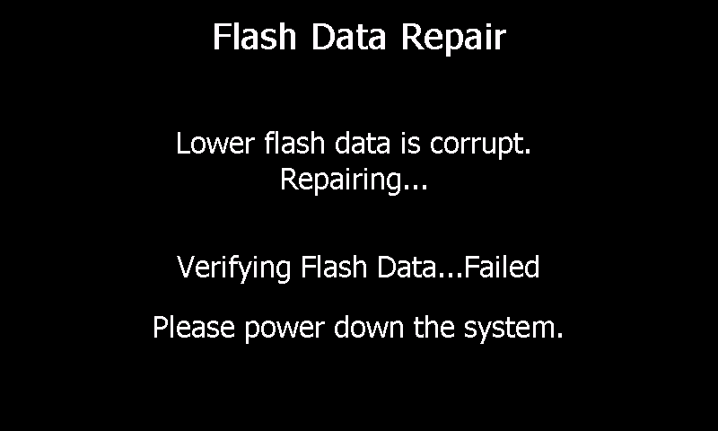

Upgrading a System Using an Upgrade File
Upgrading a system is straightforward:
- Turn target system off
- Insert USB Flash Drive into any USB slot of the target device
- Turn target system on
- A menu is presented when the device is started up, giving the user the choice of canceling the upgrade, or proceeding with it
- Informative messages are presented regarding the progress of the upgrade process
- Remove USB Flash Drive when indicated
- Power down system when indicated
Consult the references below for internal details of the upgrade process.

The USB Flash Drive can contain upgrade information for either or both of the System Software and the Motor Board Software, in any order. The System Software is always upgraded, even if the upgrade software has the same version as the installed software. The Motor Software, on the other hand, is only upgraded if the USB Flash Drive has a different version (earlier or later) than that on the Motor Board.

There are five categories of screens that are shown on the device:
- Initial screens
- System Software screens
- Motor Board Software screens
  - Motor Board Software versions are different
  - Motor Board Software versions are the same
- Final screens
- Top level error screens
In the screen shots below, please note that the version numbers shown are for illustration purposes only.

Initial Screens
On the following screens, pressing the CANCEL button causes the upgrade to immediately exit with a failed condition (Final Screen 410). Pressing START proceeds to either the System Software Screens or the Motor Board Software Screens. An Error Screen is always followed by Final Screen 410.

Motor Board Software Versions Are Different
Screen 100: Cancel Start Motor Board Versions Different
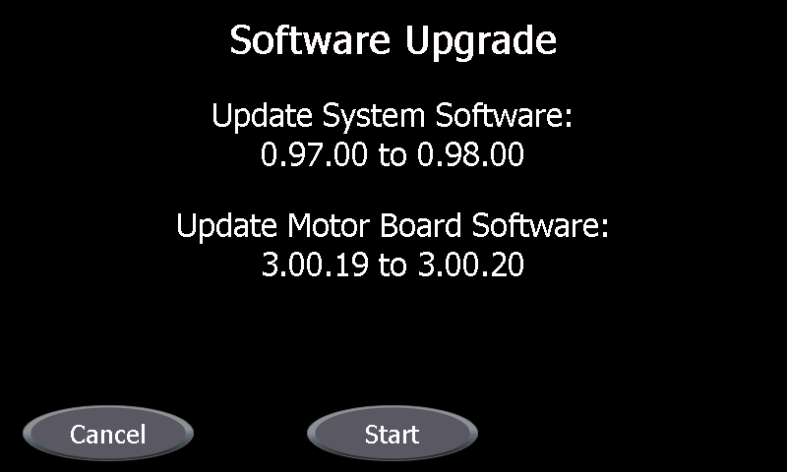

Motor Board Software Versions Are the Same
Screen 110: Cancel Start Motor Board Versions Same
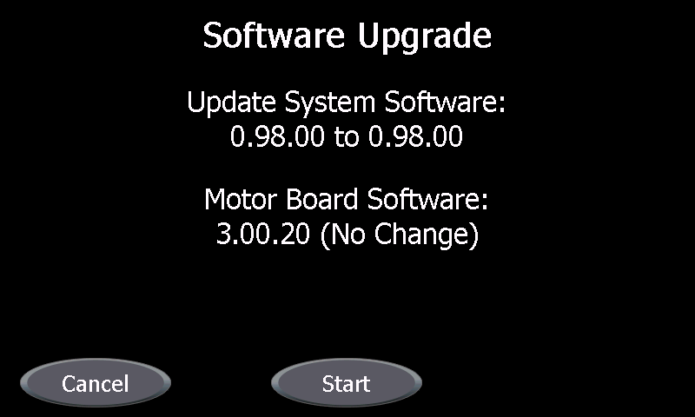

System Software Screens
These are status screens that automatically progress from one screen to the next.

The following screen shots represent a detailed mode of display. (This is achieved by inserting a Factory Mode USB key in the back of the unit). The default mode of display only will show screens 201, 202, 204.

Normal Screens
Screen 200: Reading System Image Header
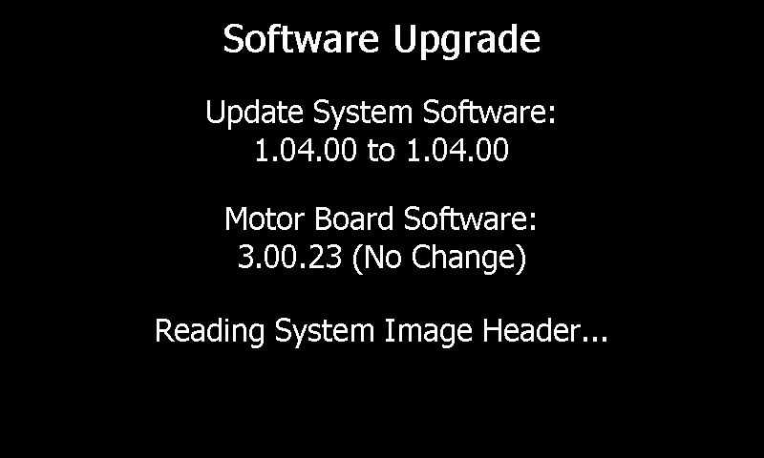

Screen 201: Reading System Image Data
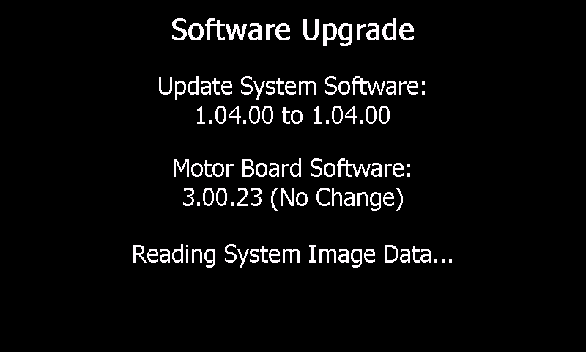

Screen 202: Writing Lower Flash Data
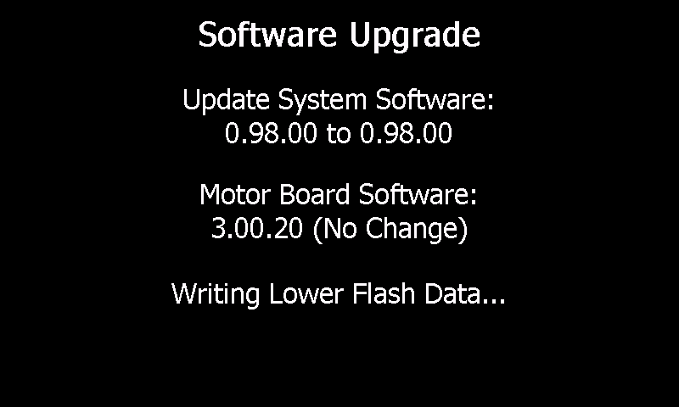

Screen 203: Verifying Lower Flash Data
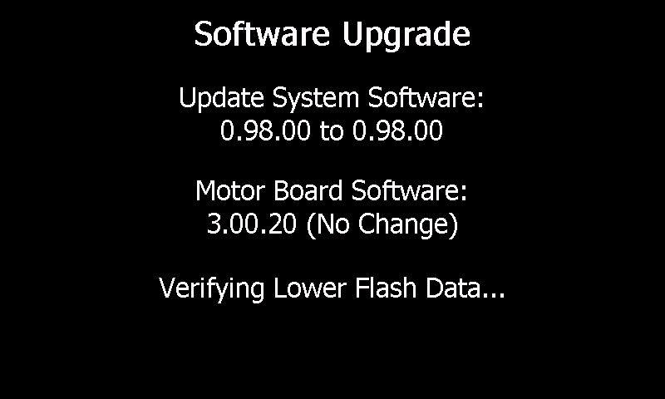

Screen 204: Writing Upper Flash Data
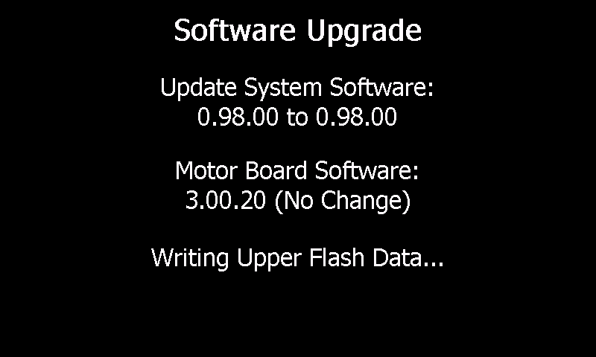

Screen 205: Verifying Upper Flash Data
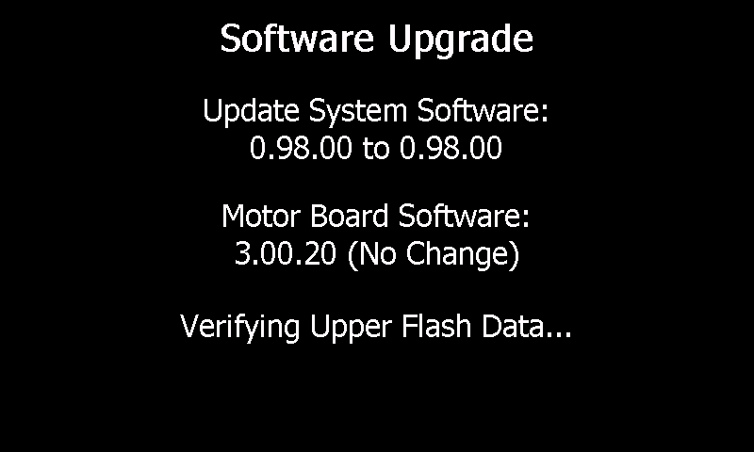

Error Screens

Screen 210: Reading System Image Header Failed
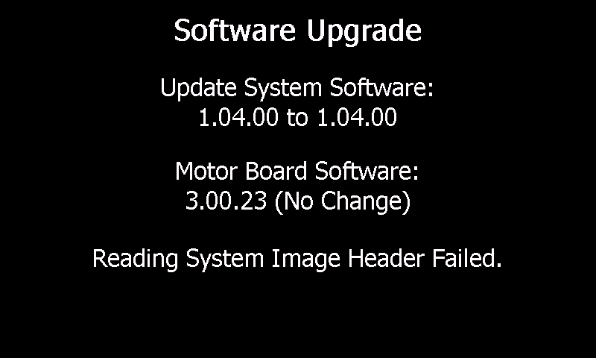

Screen 211: Invalid System Image Header CRC
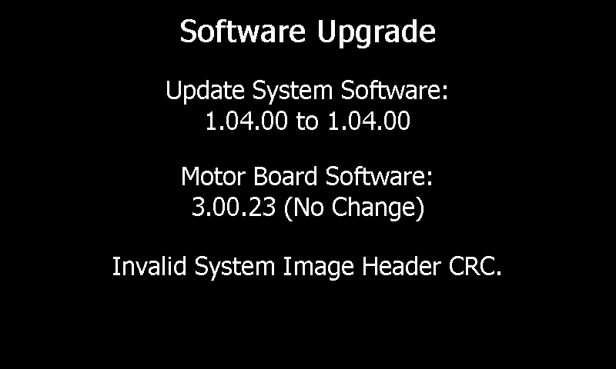

Screen 212: Error Allocating Memory for System Image
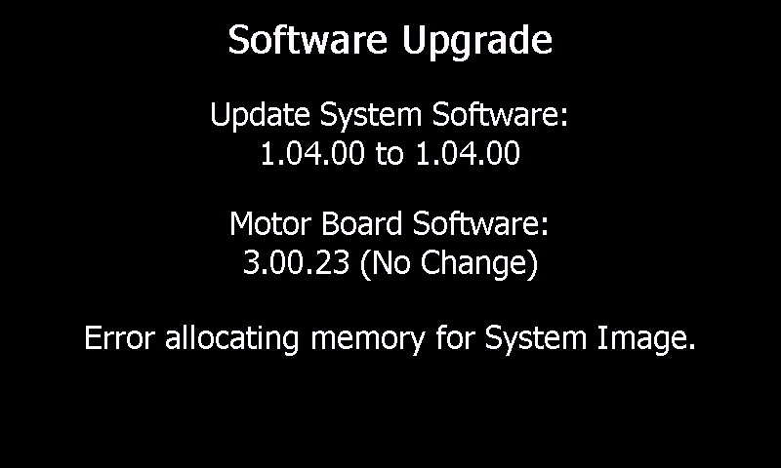

Screen 213: Reading System Image Data Failed
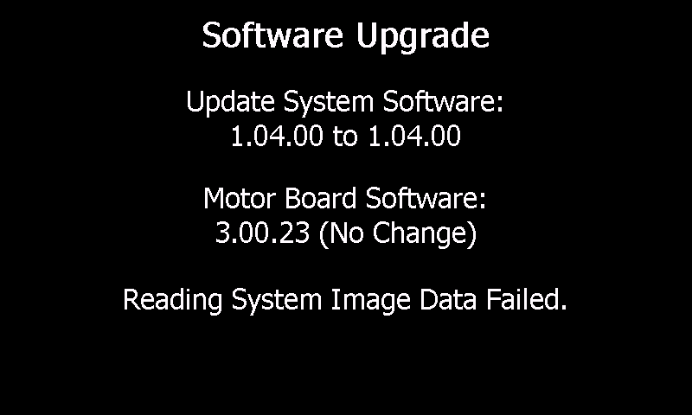

Screen 214: Invalid Splash Data CRC
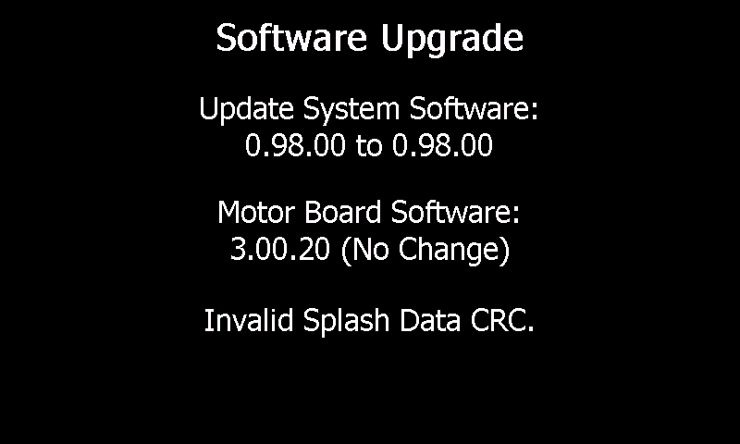

Screen 215: Invalid System Data CRC
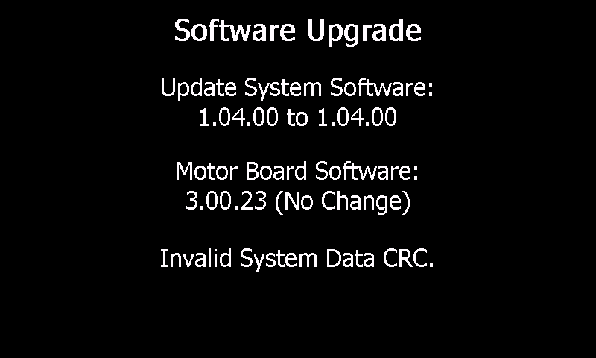

Motor Board Software Screens
These are status screens that automatically progress from one screen to the next.

The following screen shots represent a detailed mode of display. (This is achieved by inserting a Factory Mode USB key in the back of the unit). The default mode of display only will show screen 301.

Motor Board Software Versions Are Different

Screen 300: Reading Motor Board Image Header
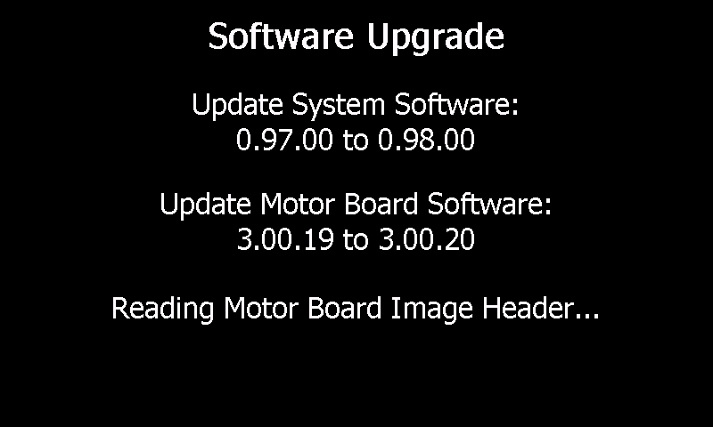

Screen 301: Updating Motor Board Program Flash
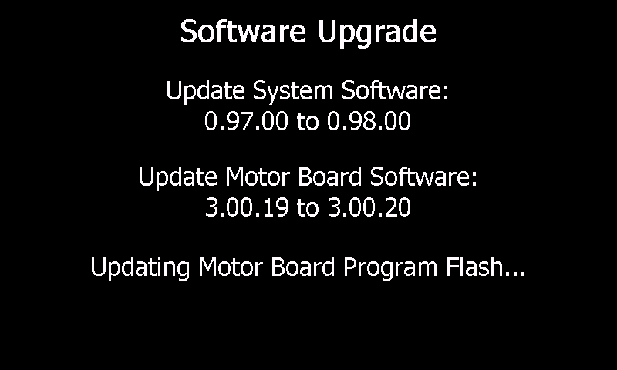

Screen 302: Updating Motor Board Data Flash
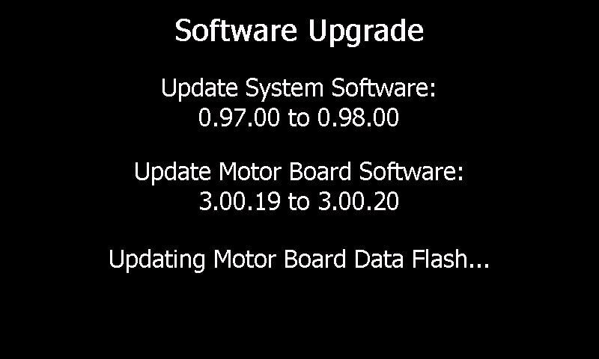

Motor Board Software Versions Are the Same
Screen 310: Skipping Motor Board Image Header

Error Screens

Screen 320: Reading Motor Board Header Failed
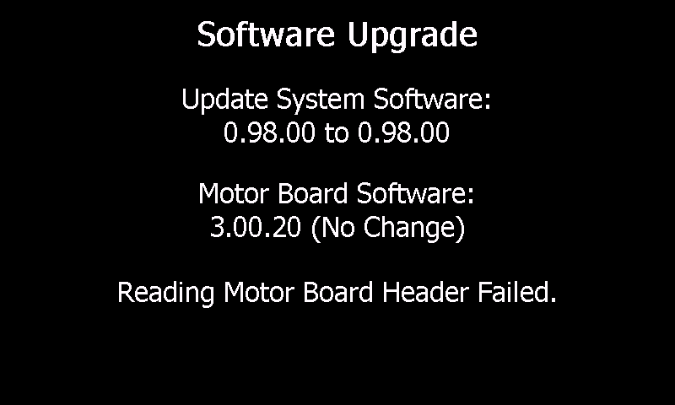

Screen 321: Reading Motor Board Program Flash Failed
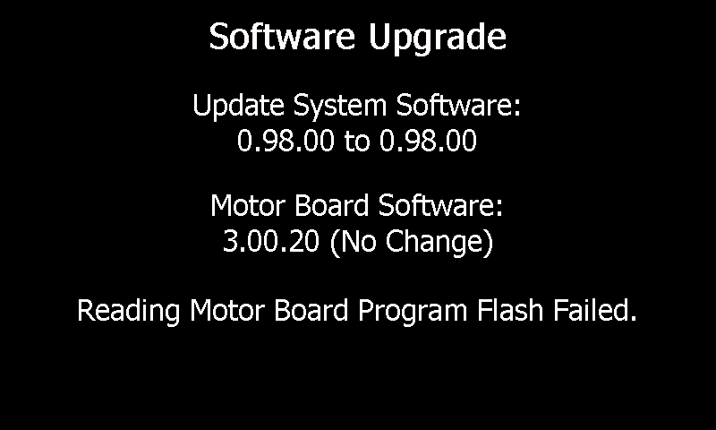

Screen 322: Reading Motor Board Data Flash Failed
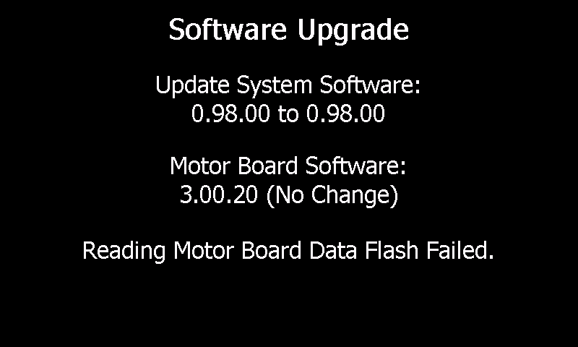

Screen 323: Invalid Motor Board Image Header CRC
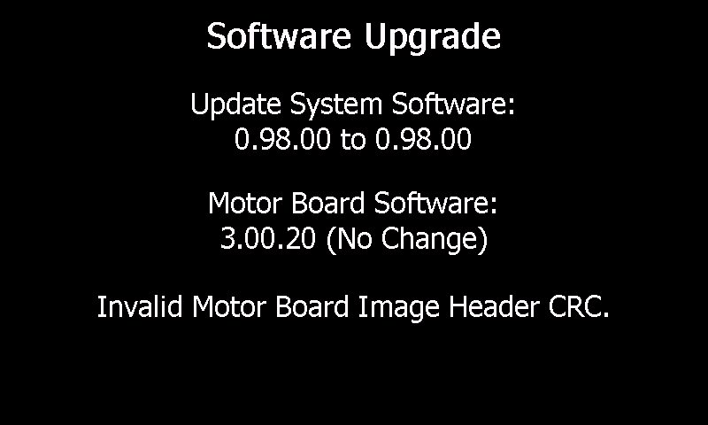

Screen 324: Writing Motor Board Program Flash Failed
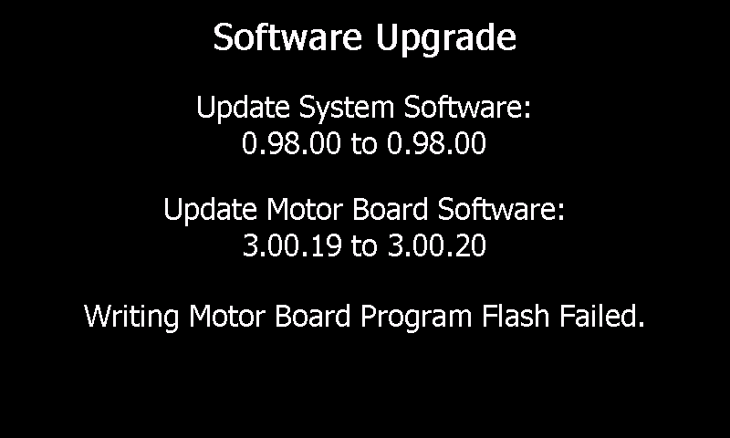

Screen 325: Writing Motor Board Data Flash Failed
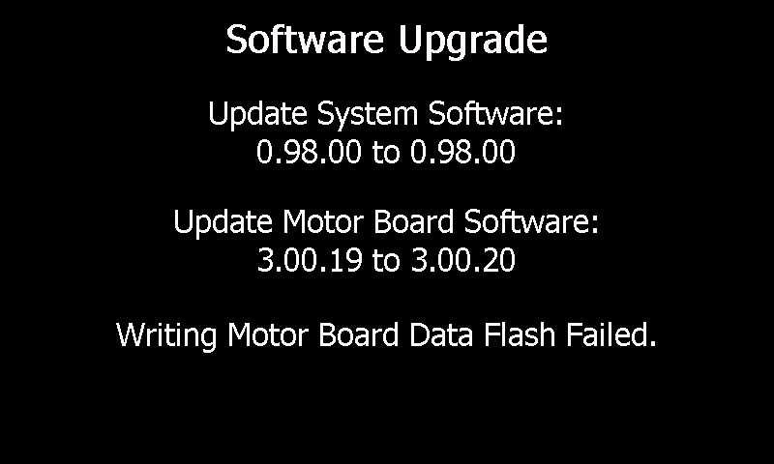

Final Screens

The following screen shots represent a detailed mode of display. (This is achieved by inserting a Factory Mode USB key in the back of the unit). The default mode of display only will show screens 400, 401, 410, 411.

Final Screens with No Upgrade Errors
Screen 400: Update Complete Please Remove the USB Drive
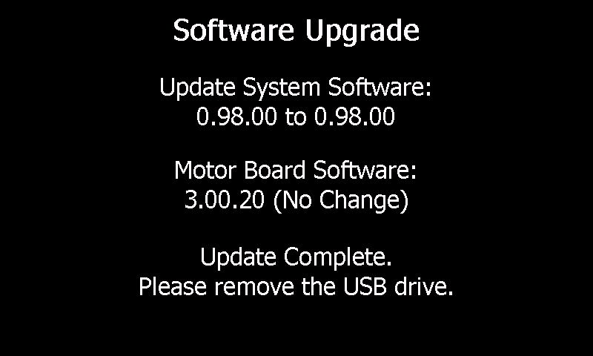

Screen 401: Update Complete Please Power Down the System
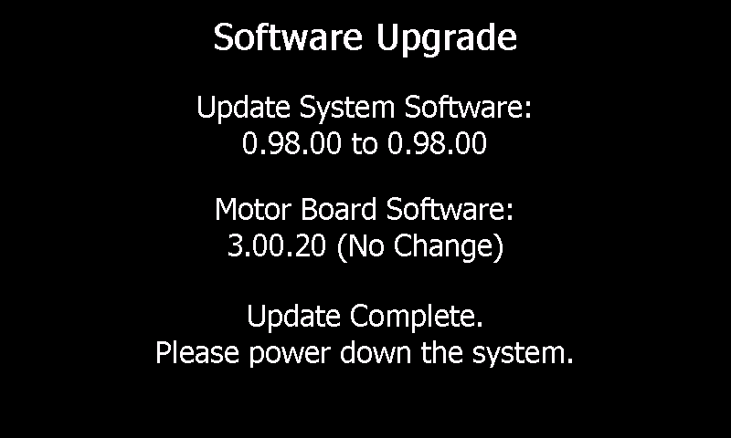

Final Screens with Upgrade Errors

Screen 410: Update Failed Please Remove the USB Drive
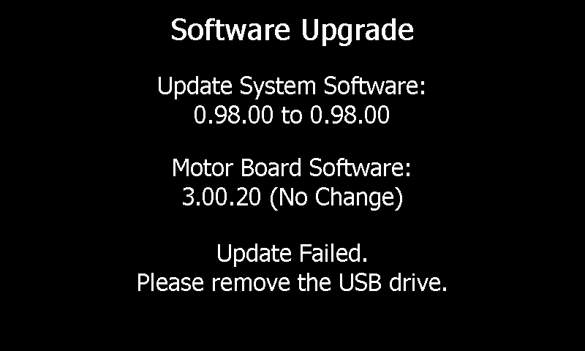

Screen 411: Update Failed Please Power Down the System
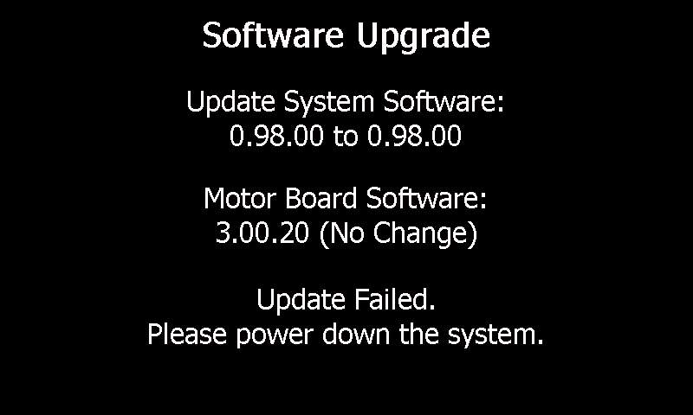

Top Level Error Screens

Screen 500: Unknown Image Header Type
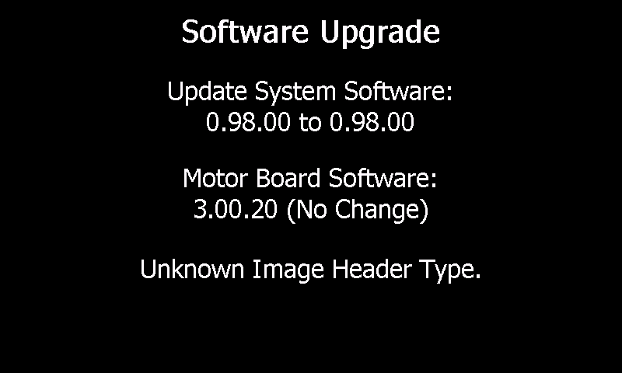

Example Screen Sequences and User Actions

USB Flash Drive Has System Software, followed by Motor Software, Versions in System Are Different, No Update Errors
100, Press START on screen 100, 200, 201, 202, 203, 204, 205, 300, 301, 302, 400, Remove USB Flash Drive from system, 401, Power Down System

USB Flash Drive Has System Software, followed by Motor Software, Versions in System Are Different, Update Error
100, Press START on screen 100, 200, 201, 213, 410, Remove USB Flash Drive from system, 411, Power Down System

USB Flash Drive Has System Software, followed by Motor Software, Versions in System Are Same, No Errors
110, Press START, 200, 201, 202, 203, 204, 205, 310, 400, Remove USB Flash Drive from system, 401, Power Down System

USB Flash Drive Has Motor Software, followed by System Software, Versions in System Are Different, No Errors
110, Press START, 300, 301, 302, 200, 201, 202, 203, 204, 205, 400, Remove USB Flash Drive from system, 401, Power Down System

References
Operation of Motor Controller Bootstrap Code doc
Windows CE Flow.doc

